ORCA

European Organization for Caries Research

**President:** Prof. Dr. C. Splieth

**Secretary-General:** Prof.Dr. Ir. M.H. van der Veen

.

**Minutes -ORCA BOARD MEETING**

**online, Friday 9 July 2021: 17:35-18:35 Central European Summer Time**

1. The **meeting was opened** by the ORCA president Christian Splieth
2. The **Minutes of the previous General Assembly** held online Friday 10 July 2020 and the Agenda for the present meeting were approved.
3. **Matters arising:** 
   1. The general assembly stood still at the passing of Prof. Thomas (Tomi) Marthaler and Prof Walter Künzel honorary members of ORCA by a minute of silence. Their in memoriam can be found on the ORCA website.
   2. The text regarding the objective of the ORCA prize has been adapted to widen its scope: As formulated in the Announcement of the ORCA Prize (in *Caries Research* and on the ORCA website): ”This prestigious prize is given to **individuals, groups or organizations** in recognition of their outstanding contributions to matters concerning dental caries. Only ORCA members can make nominations for the prize, but nominees need not be ORCA members. Moreover, there are no restrictions for nominations with respect to age or seniority, and persons who have previously been nominated unsuccessfully can be renominated. **The main qualification is their impact in cariology which can be original research work in cariology, the promotion of caries research, the implementation of cariology into practice and major contributions to oral health with special respect to caries.** Cariology also includes other hard tissue disorders. The committee should evaluate a broad range of parameters including societal and scientific impact.
   3. On 1 October 2021 ACTA organizes a Farewell symposium for Hans de Soet. The preliminary program is listed on the ORCA website. The symposium can be followed online. Details will be provided in due course via the ORCA website.
4. **Nominations and election to office** 
   1. Nominations to fill 4 vacancies on the advisory council were received for: Muthu Murugan; Alexandre Vieira, David Manton, Shashirekha Govind, Ana Carolina Magalhães, Klaus Neuhaus, Juan Sebastian Lara, Fabian Cieplik, Marcella Esteves Oliveira, Mariantonietta Arrica, Sonali Sharma, Benedikt Luka and Catherine Volgenant. Voting has been set-up to take place via the ORCA website. All members will be notified of the elections via mail. Deadline for voting is July 31.
   2. Prof. Margherita Fontana from Ann Arbor, Michigan, USA has been elected Vice-President by the membership. We welcome her onto the board.
   3. The board has selected Ass. Prof. Ruth Santamaria from Greifswald, Germany as new Chair of the Education Committee, which was accepted by the general assembly.
5. **Reports:** 
   1. **President**

* **Uniform decision of board for online congress**
* **Educ Platform 2020:** Steered clear interest in Asia, esp. India and Arabia => Publication on the way
* **ORCA & EFCD consensus “How to intervene**” publications translating the consensus reports to general practice: Spanish South America by Rodrigo Giacaman et al.; In Germany 3 online lectures were given with German Assoc Operative Dent;
* Serbia: adults…after children are done; Croatia on its way; Italy/Switzerland by Guglielmo Campus et al.
* **ORCA & EFCD consensus on “Caries Diagnostics”:** Several meetings of steering committee were held as well as meetings of subgroups (detection, activity/progression, full diagnosis). Look into existing literature, system reviews, terminology, consensus treatment. Recommendations for clinical practice => latest 2023 on congress with EFCD
* The EU is preparing a **silica ban**, which stirred the tooth paste manufacturers. ORCA was asked to support a request by the platform for better oral health in Europa to plea for continued use of silica in toothpaste.
* Thank you to advisory council members for writing content for the ORCA website:

|  |  |  |
| --- | --- | --- |
| Name | Topic | Month |
| Aylin | Consensus Root Caries | March |
| Ruth | Consensus Children | April |
| Rodrigo | Consensus Approximal Caries | May |
| Peter | Consensus Secondary Caries (+questionnaire ?) | June |
| Marianna | SDF | July |
| Marisa | Sealing Caries (including deep dental caries) | Aug |
| Gail | Evidence-based Community Dentistry | Sept |

* 1. **Membership Secretary & Webmaster**
* First, a big THANK YOU to my predecessor, Livia Tenuta! She was extremely helpful during the transition phase and ever since.

**Membership Update**

New Membership Applications

Fewer applications received in 2021 compared to 2020 thus far. Many new membership applications do not result in memberships as applicants do not pay their membership fees.

ORCA has members from 47 countries.

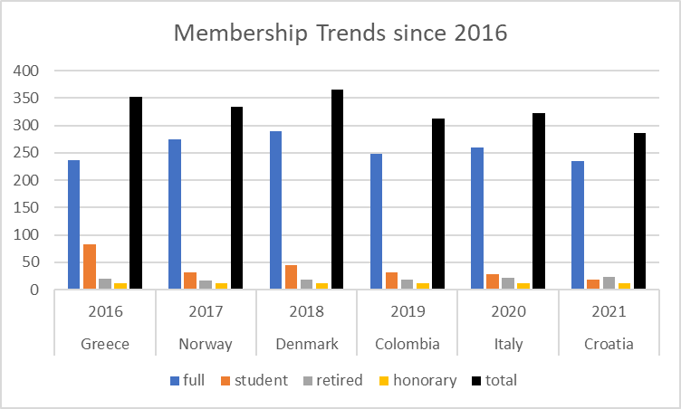

*

*introductory

There has been a worrying overall trend in declining membership for ORCA.

Changes between 2020 and 2021 by country:



Next steps:

* Membership satisfaction survey (Qualtrics, July)
* Clean-up of membership database

**Webmaster Update**

1. New Web Summaries published on ORCA website (https://orca-caries-research.org/web-summaries).

Current list of web summaries:

ORCA website:

* External ORCA Congress website (e.g., more functionality, better layout)
* Migration to new web content management framework currently underway, to be completed mid-July
* All current content will be migrated
* No website outage expected
* Newsletter function will work again

Communication with ORCA Members:

* Please log into your account to ensure your contact details are up to date.
* Please email membership@orca-caries-research.org if you have difficulties logging in or forgot your password.

Accessing Caries Res & Monographs in Oral Science:

Several members reported difficulties in accessing ORCA’s publications.

If anyone still encounters any issues, then please follow these steps:

* Delete cookies & browsing history
* If unsuccessful, you may have to use another network

Next steps:

* Advisory Board election (ORCA website)
* Planned for Q4: automatic invoicing & immediate payment required for new membership applications

Special thanks to:

* Anahita Jablonski-Momeni
* Monique van der Veen
* Christian Splieth
* All other ORCA Board and all Advisory Board members
  1. **Treasurer report** Period 01.01.-31.12.2020 Prof. Anahita Jablonski-Momeni, Marburg, Germany

**Corporate Members**

Many thanks for the continuous support of ORCA

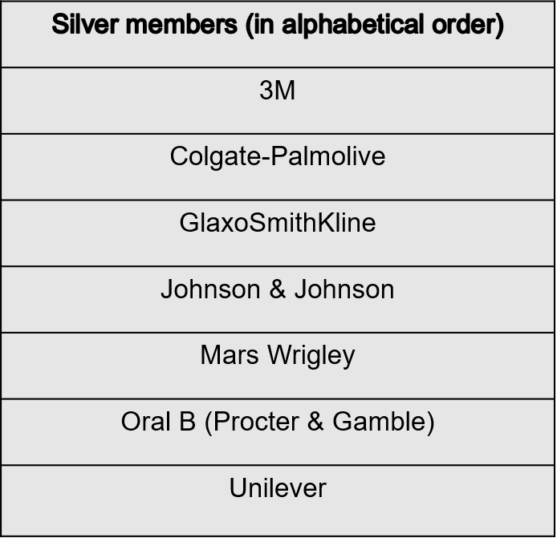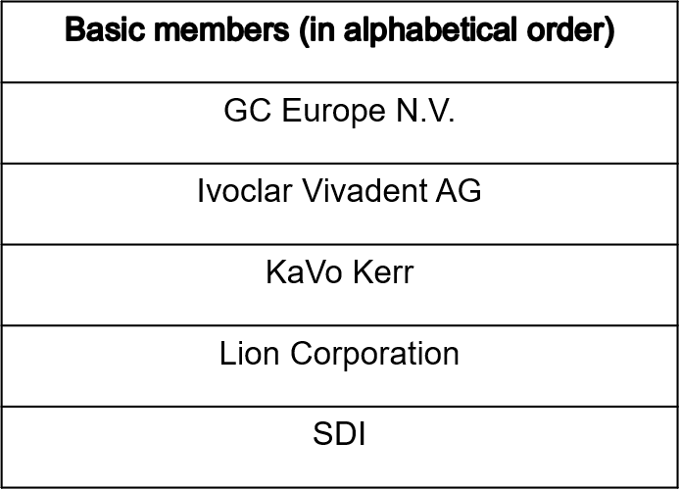

Acknowledgement of financial support in Caries Research 2020:

https://www.karger.com/Article/Abstract/513546

**Individual Members**

**Invoice and payment work flow:**

Payment Status for 2021 (as of June 30, 2021)

Members with status “not paid”:

According to the ORCA bylaws and in compliance with the General Data Protection Regulation (GDPR) the membership will be terminated by 30 June 2021.

**Payment possibilities:**

* Preferred way for SEPA (Single Euro Payments Area) countries: Bank transfer
* Introduced in 2020 (and well accepted): PayPal by e-mail
* For all others: Credit card (MasterCard / Visa)

Although clearly communicated in the invoice, many members who would be able to transfer the money (SEPA countries) still pay by credit card. The fees are charged to ORCA and are up to 8 € per transfer depending on the country/bank/type of card etc. PLEASE use bank transfer or PayPal payment whenever possible. The ORCA board is working on a solution to pay through the website.

**Some general remarks:**

* If you use spam filters in your email account, please check in your spam for messages or emails from:
  + treasurer@orca-caries-research.org or
  + momeni@staff.uni-marburg.de
* Please declare members NAME and ORCA ID for payment (for bank transfer or PayPal). If you choose the credit card option: ORCA accepts MasterCard / Visa. Please don´t ask for other card types. Please check the authorization for your credit card (payment in Europe/Germany). ORCA doesn't offer a link for online payment system at the moment. Please use the payment options given in the invoice (all are convenient for payment). Next invoices will be sent October 2021:

Please pay the membership fee on time to avoid reminders.

**Profit and Loss Statement**

**Outlook**

**Karger 2021**

According to the negotiations from 2020:

Karger paid for Editor + support for EBM (25,000 CHF = 22,866.97 EUR)

To get free access to:

* to the Journal Caries Research ORCA paid 37 CHF (~ 34 €) for each member with full fee and 30 CHF (~ 28 €) for each member with reduced fee = 10,589 CHF
* the Monographs in Oral Science ORCA paid 3900 CHF

= ORCA paid 13,514.34 EUR to Karger.

So please feel free to use the Journal and the Monographs since this is an important benefit for ORCA members (who paid their fees).

**Acknowledgements:**

Special thanks to: Frank Lippert, Monique van der Veen and Christian Splieth +

Many thanks to: all board-, corporate- and individual members

* 1. **Editor**

Many thanks to the Associate Editors:

Paul Anderson

Girvan Burnside

Joana Carvalho

Jaime Cury

Anderson Hara

Marie-Charlotte Huysmans

Marisa Maltz

Hendrik Meyer-Lueckel

Bente Nyvad, retiring associate editor

Nobuhiro Takahashi

and recently appointed associate editors:

Dongmei Deng

Rodrigo Giacaman

Vita Maciulskiene

David Manton

**The Scientific Programme Committee** (Vice-President, Co-President and Editor)

* 119 abstracts were submitted
* very few rejected (out of scope or had no scientific content)
* most of the abstracts needed revision e.g. because they did not contain numerical data and statistics
* abstract publication is finalised, new format saved a lot of time and efforts

**The Steering Committee** (Vice-President, Co-President, Past Co-President, Editor, Congress Team)

* met several times, good discussions
* handling of submissions much improved
* abstracts sent to Karger in good time
* Issues around Congress organisation and programme from the Co-President

**The Journal**

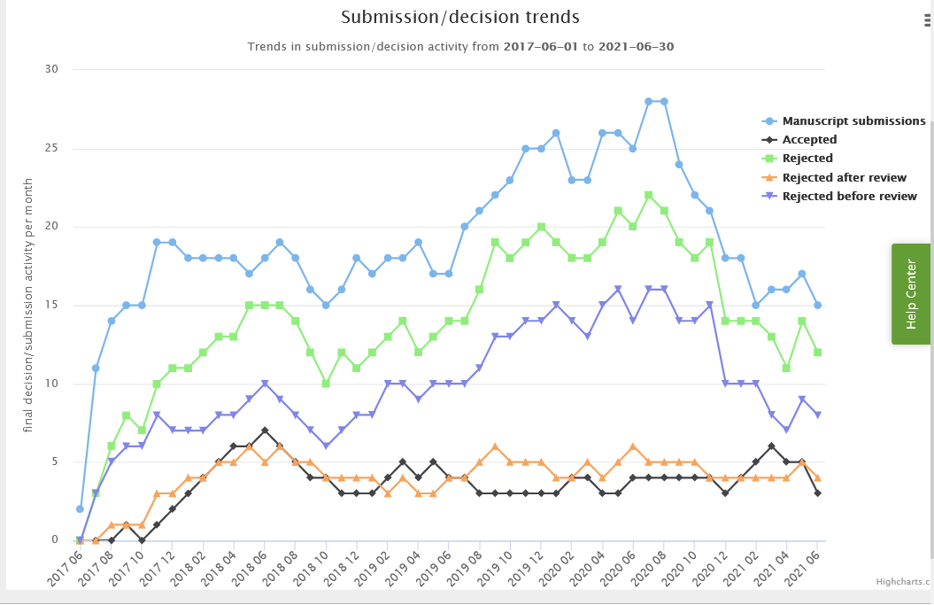

In 2021: so far 96 submissions

2020 Impact factor: 4.056 (Q1)

2020 CiteScore: 5.2

**Submission by country:**

Thank you all! Submitters, reviewers, associate editors, publisher

1. Reports of the Working Groups and Committees
   1. **ORCA Education Committee**

* **Spanish Version of a Cariology Curriculum**

The proceedings of the respective consensus workshop and the content have been accepted on 14 June 2021 by European Journal of Dental Education

* **Scientific Committee for Education Platform 2021**

Continued to have online meetings once a month since last ORCA General Assembly

Members are Andreas Schulte, Marie-Charlotte Huysmans, Joana Carvalho and Stephanie Tubert-Jeanning (ADEE representative)

My sincere thanks go to Marie-Charlotte, Joana and Stephanie for the extremely fruitful and nice cooperation

* **Joint ORCA/ADEE Education Platform 2021**

In view of the 10th anniversary of the publication of the European Cariology Core Curriculum an interesting 4-hour-program was developed. Lectures of Main Speakers:

* + Andreas Schulte: Impact of the European Cariology Core Curriculum
  + Javier Cortes: A National Cariology Curriculum Consensus Conference as a Chance for Interdisciplanary Communication – the Spanish Example
  + Svetlana Tikhonova: Building a Consensus on a Core Cariology Curriculum: The Canadian National Symposium
  + Nigel Pitts: ACFF - Global Examples of Localisation and Implementation of the European Cariology Core Curriculum
  + Stephanie Tubert-Jeannin: Update of Curricula in Oral Health Professionals’ Higher Education –the European Perspective
  + Svetlana Tikhonova: Implementation of Curricula - How to approach this Challenge
* Ten abstracts on novel ways of teaching cariology:
  + Encouraging high number of interesting submissions of good quality for this year‘s ORCA congress.
  + Research in education in cariology in the future regular part of ORCA congresses?
* **Publication of the invited lectures of the ORCA/ADEE Education Platform**

The Scientific Committee has prepared a frame for a common concise publication of the main lectures of the

Aim is to submit the ready manuscript in 2021

Many thanks to the Editor of Caries Research for her support of this project!

* **Joint ORCA/ADEE Education Platform Online**

Many thanks to the Board of ADEE that this joint Education Platform could take place.

Many thanks Hrvoje Juric and his team for the hard work!

* **ORCA Education Platform**

Part of the ORCA congresses since ORCA congress 2012 in Liverpool

* **Many thanks to the ORCA Boards since 2007**

ORCA Education Committee started as Cariology Curriculum Committee in 2007

Task: to prepare the European Cariology Core Curricum

Members of the CCC were: Marie-Charlotte Huysmans, Nigel Pitts, Andreas Schulte, Wolfgang Buchalla, Christian Splieth

* **New chair of the Education Committee**

With this General Assembly my term as chair and member of the ORCA Education Committee ends.

My best wishes for a successful time go to my successor!

* 1. **ORCA Prize/Yngve Ericson Prize:** In 2022 the Yngve Ericson Prize will be awarded
  2. **Working Group for Stimulation and Promotion of Research into Caries**

It was a busy year:

Anniversary European Cariology Core Curriculum, celebration last Wednesday

Steering group for the 2021 Congress

* **Committee for Stimulation & Promotion of Research into Caries**
* **Summer school**: Plans for India. Progress delayed due to COVID surge in India
* **SAS**:

2022: Cagliari, provisional theme: limitations to personalized prevention

2023: Netherlands, theme ‘where cariology meets restorative dentistry’

* **Travel fellowships**

**28 applications, 9 awarded:**

Meghna Prakash from India

Vesna Ambarkova from macedonia

Ece Yilmazkasapoglu Türkay fron Turkey

Haoran Chen from China

Angela Rovera from Italy

Sonali Sharma from India

Magdalena San Martin from Uruguay

Kasidid Ruksakiet from Thailand

Latha Anandakrishna from India

CORONA = NO TRAVEL = FREE REGISTRATION

* **NATHAN COCHRANE JUNIOR SCIENTIST AWARD**

18 applications originally, of whom 15 presented their work on Thursday

Members of the jury: Joana Carvalho, Aylin Baysan, Ruth Santamaria

AND THE WINNER IS….. To be revealed tomorrow at the closing session

1. **Future venues of Congresses of ORCA**
   1. Cagliari, Sardinia, Italy 2022 Gugliermo Campus

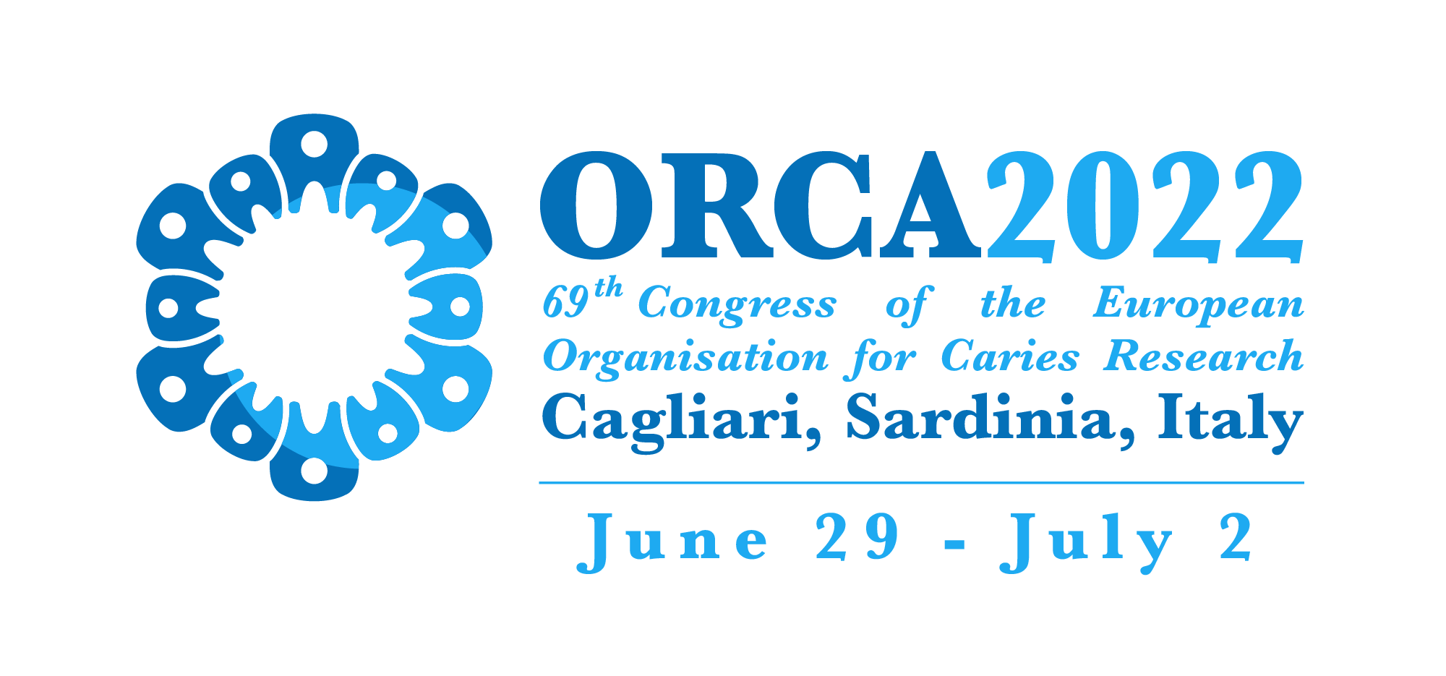

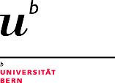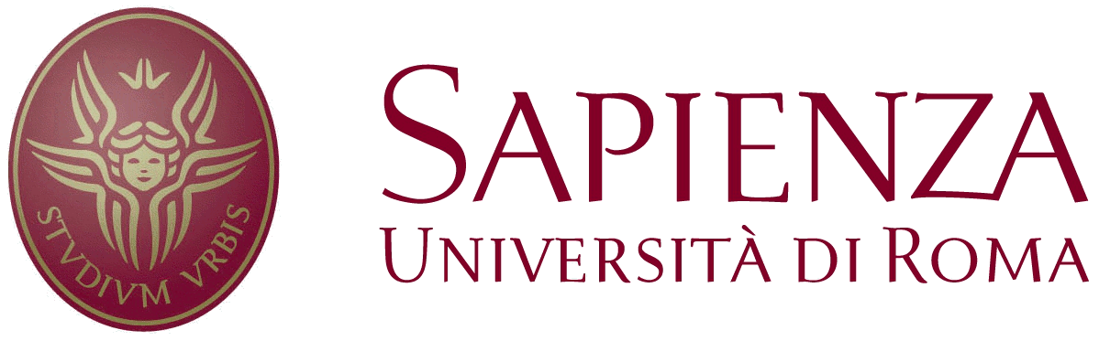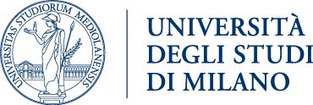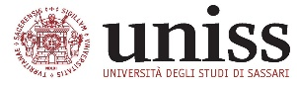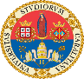

UNIVERSITA’ DEGLI STUDI DI CAGLIARI

**UNDER THE PATRONAGE OF:**



* 1. Amsterdam (Egmond aan Zee), the Netherlands 2023
  2. Crete, Greece 2024

1. **Any other business** No other business was brought forward.
2. **Close of session**

P.S. Election advisory council. Elected were David Manton, Catherine Volgenant, Juan Sebastian Lara and Klaus Neuhaus.