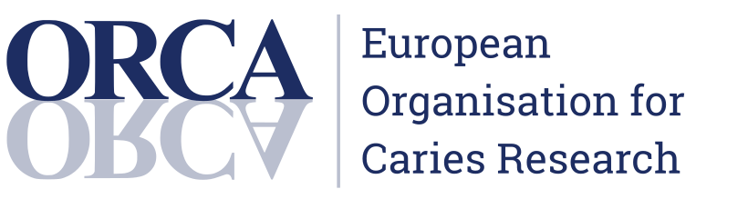

2024 SPRING WEBINAR
Are there Alternatives to Fluoride for Caries Management?
Saturday April 6, 2024 - 11 am - 1 pm ET

Introduction of each association, webinar and speakers - 11:00 to 11:05 am ET
AAC President: Dr. Carlos Gonzalez
ORCA President: Dr. Margherita Fontana

Session 1 - 11:05 to 11:25 am ET
How to Identify and Manage Fluoride Hesitancy in Clinical Practice
Speaker: Dr. Donald Chi
Despite the proven safety and effectiveness of fluoride for caries management, fluoride hesitancy among patients is a growing clinical problem. Clinical fluoride hesitancy mirrors community-level opposition to water fluoridation and vaccine hesitancy in medicine. Concerns about fluoride include its necessity, potential side effects and incomplete or inaccurate understanding of its evidence for caries management. The presentation will emphasize the reasons for fluoride hesitancy and clinical strategies to manage fluoride hesitancy in practice.

Session 2 - 11:25 to 11:45 am ET
Alternatives to Fluoride in the Prevention and Treatment of Dental Caries
Speaker: Dr. Domenick Zero
Although fluoride remains the most effective and widely used caries management strategy, there is increasing interest in other approaches. The presentation will provide an overview of current evidence on potential fluoride alternatives for caries management.

Session 3 - 11:45 am to 12:05 pm ET
How to Build Evidence through Clinical Trials and Clinical Guidelines
Speaker: Dr. Jan Clarkson
The presentation will discuss tools to improve clinical research design, conduct and reporting and to increase usability of research.

Session 4 - 12:05 pm to 12:55 pm ET
Q & A: all speakers
Moderators: TBD

Closing remarks - 12:55 pm to 1:00 pm ET
AAC President: Dr. Carlos Gonzalez (announce AAC 2024 Conference)
ORCA President: Dr. Margherita Fontana (announce ORCA 2024 Conference)

